Midwest Water Resources

Developing an Evapotranspiration Climatology to Analyze Spatiotemporal Water Budget Patterns for Agriculture and Natural Resources Managers in the Midwest

 **Technical Report**

Final – November 18th, 2021

Emma Myrick (Project Lead)

Alec Solberg

Erin Shives

Erica Barth-Naftilan

***Advisors:***

Molly Woloszyn, NOAA National Integrated Drought Information System (Science Advisor)

Dr. Olivier Prat, NOAA National Centers for Environmental Information, North Carolina Institute for Climate Studies (Science Advisor)

Dr. Brian Nelson, NOAA National Centers for Environmental Information (Science Advisor)

# 1. Abstract

Evapotranspiration (ET) is a climatic variable critical to the hydrologic cycle and is used to evaluate spatiotemporal trends in drought conditions. Although *in-situ* observations provide accurate ET information, these records are spatially sparse. The United States Department of Agriculture (USDA) Midwest Climate Hub, National Integrated Drought Information System, Minnesota Department of Agriculture, Michigan State University, and the USDA Foreign Agricultural Service have partnered with DEVELOP to gain new insights on spatiotemporal patterns of ET with NASA satellite data. This project evaluates the feasibility of using remotely sensed ET data products to understand trends from 2001 through 2020. Actual ET (aET) data were sourced from NASA’s Terra Moderate Resolution Imaging Spectroradiometer (MODIS), and reference ET (refET) and precipitation data were sourced from the Gridded Surface Meteorological Dataset (gridMET). Spatial and temporal differences in the MODIS and gridMET data sets were resolved such that gridded data could be compared. These data sets were then used to produce monthly Normals maps of mm/8-day of precipitation, aET, and refET. Using precipitation and ET Normals maps, hydrologic state maps were produced by subtracting either refET or aET from precipitation. These hydrologic state maps provide a proxy water balance by summarizing the difference between water entering and leaving the ground surface. Additionally, the ET products were compared in timeseries plots. The ET products from this project provided partners with comparable datasets to assess potential drought and flooding conditions to support Midwest agricultural and natural resource managers in decision-making.

**Key Terms**

Terra MODIS, gridMET, timeseries, climatology, evapotranspiration, precipitation, Midwest, water balance

# 2. Introduction

***2.1 Background Information***

The Midwest region of the United States encompasses some of the most agriculturally productive land in the nation. The availability of resources provided by Midwest agriculture is heavily influenced by seasonal climatic shifts and hydrologic conditions. Evapotranspiration (ET) is a climatic variable critical to the hydrologic cycle and can be used to evaluate potential drought conditions (Hussain et al., 2019).ET is a measure of water vapor’s return to the atmosphere via evaporation from the ground surface or transpiration from plants (USGS, 2021). Reference ET (refET) is a measure of atmospheric demand calculated from meteorological variables and based on the assumption that water is not limited in the subsurface. Due to this assumption, refET generally overestimates the actual evapotranspiration (aET). Actual ET is more difficult to measure as it requires more variables to be accounted for, including interception of rainfall by plants, availability of soil moisture, or access of plant roots to the water table, among others (Fetter, 2001). As a result, aET is primarily measured at *in-situ* stations, which limits the availability of aET data across space.

Prior research suggests that remotely sensed aET products may allow for estimates of aET across a larger spatial extent (Niyogi et al., 2020).For example, Niyogi et al. (2020) evaluated climatological trends of aET in the state of Indiana and compared them with *in-situ* measurements. Based on the Niyogi et al. (2020) findings, aET measurements derived from Moderate Resolution Imaging Spectroradiometer (MODIS) sensors can provide a reasonable estimation of aET. This project used Terra MODIS data from the start of the MODIS period of record (2001) to the most recent complete year of data (2020) to create an average aET record for the Midwest region. The Gridded Surface Meteorological (gridMET) dataset offered suitable refET and precipitation data for this research. This dataset aims to provide high resolution and spatiotemporally comprehensive climate data (Abatzoglou, 2013).

***2.2 Community Concerns***

Often referred to as the “Corn Belt,” the Midwest generates over $76 billion in crop and livestock production per year (USDA, 2017). The impacts of extreme weather events and other consequences of climate change create adverse effects on agricultural productivity in the Midwest. ET plays a major role in the water cycle and is affected by rising temperatures, limited canopy conductance, increasing atmospheric carbon dioxide, and changes in land use (Katul et al., 2009). These effects will continue to disrupt irrigation schedules, growing seasons, and overall ecosystem health (Konapala et al., 2020) in one of the most agriculturally intensive regions in the world. The assessment of seasonal variability in ET supports agricultural and natural resource managers in decision making related to issues such as land use practices, water resource management, and drought mitigation strategies.

***2.3 Project Partners & Objectives***

Partners for this project included: i) the United States Department of Agriculture (USDA) Midwest Climate Hub; ii) the NOAA National Integrated Drought Information System (NIDIS) Midwest Drought Early Warning System; iii) the Minnesota Department of Agriculture, Pesticide and Fertilizer Management Division; iv) Michigan State University, Department of Geography, Environment, and Spatial Sciences; and v) the USDA Foreign Agricultural Service. The Midwest lacks sufficient historical climate context of ET. The partners were interested in exploring the changes in ET over time to better understand its impacts. Given the partners’ needs, three objectives were defined for this project. The first objective was to create aET, refET, and precipitation climatology maps derived from Terra Moderate Resolution Imaging Spectroradiometer (MODIS) and the University of Idaho gridMET dataset. The second objective was to create a timeseries for the aET and refET products to visualize trends over the study period. The third objective was to utilize these products to calculate actual and potential hydrologic state maps which identify areas historically prone to floods or drought. Together, these products provide partners with a temporally and spatially comprehensive ET assessment of the region.

***2.4 Study Area & Period***

Remotely sensed data were collected in nine Midwestern states including Minnesota, Michigan, Ohio, Wisconsin, Iowa, Indiana, Illinois, Missouri, and Kentucky (Figure 1). The study period covered 20 years from January 2001 to December 2020. To provide background on the study area, Figure 1 shows land cover classifications according to the 2019 National Land Cover Database. The majority of land cover in the study area is classified as cultivated crops, shown in light green.

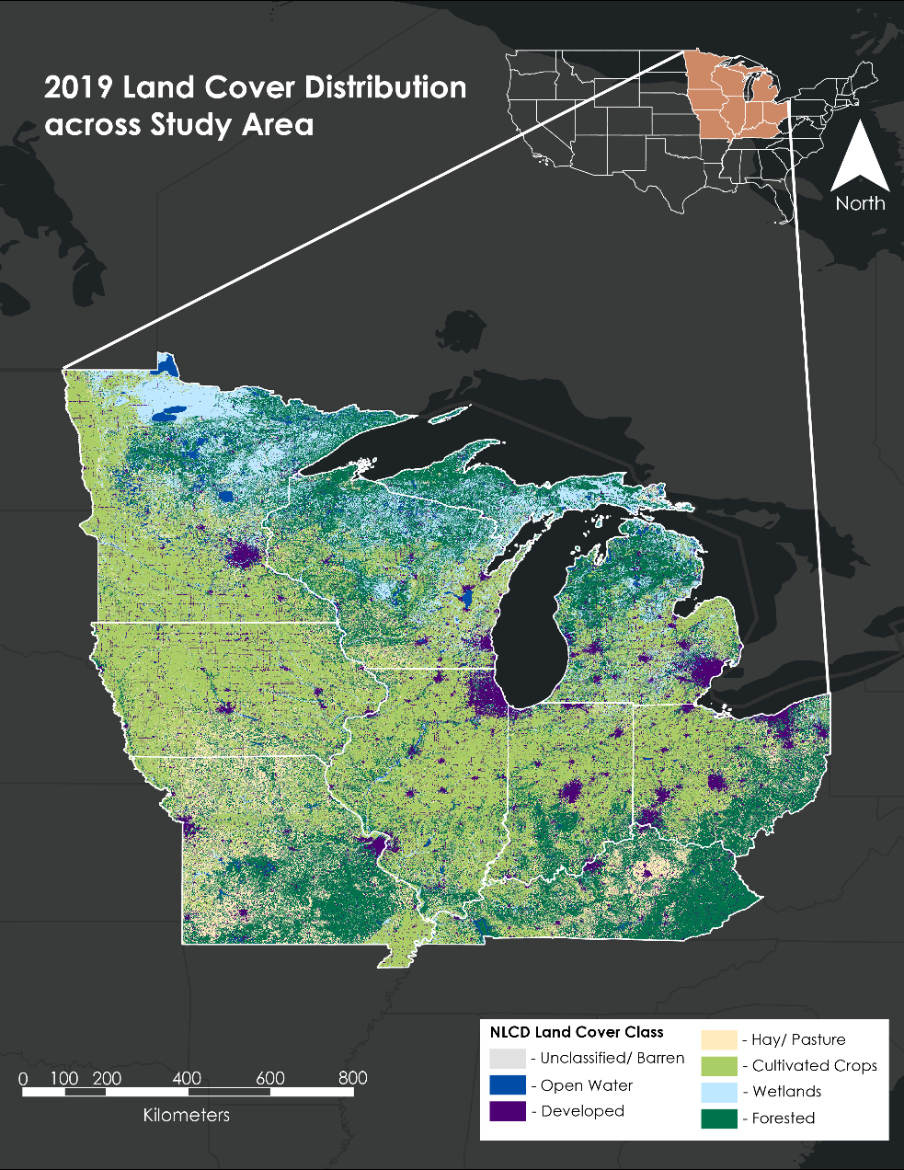

*Figure 1.* Study area map with the National Land Cover Database classification across the Midwest.

# 3. Methodology

***3.1 Data Acquisition***

The ET data product MOD16A2 Version 6 is an ET dataset derived using a Penman-Montieth-based algorithm to process data from NASA’s Terra MODIS (Running et al., 2017). The algorithm uses remote sensing inputs, including landcover and albedo, and combines them with meteorological inputs to derive an 8-day composite (sum) of ET. The team analyzed MOD16A2 images from January 1, 2001 (the earliest available) to December 31, 2020 using the Python API for Google Earth Engine (GEE). This temporal range only included complete years of data. The MOD16A2 data were used for the project’s estimated aET data.

The team also used the gridMET dataset, which is derived from merging high spatial resolution data from Parameter-elevation Regressions on Independent Slopes Model (PRISM) and high temporal resolution data from Phase 2 of the North American Land Data Assimilation System (NLDAS-2). This provided gridded meteorological data and derived variables at a 1/24th degree (~4km) spatial resolution and daily temporal resolution (Abatzoglou, 2013). Variables used from gridMET included precipitation (‘pr’) and evapotranspiration with reference to alfalfa (‘etr’). The ET data from gridMET were used for the project’s refET data.

In addition to imagery, sampling points were needed to create timeseries plots. The team selected one research station from each state in the study area. These stations were chosen such that agricultural land cover would be consistent amongst the timeseries points.

*Table 1*: Research stations in each Midwestern state gathered for timeseries plots.

|  |  |
| --- | --- |
| **State** | **Research Station** |
| Minnesota | University of Minnesota Southwest Research and Outreach Center |
| Michigan | Michigan State University W.K. Kellogg Biological Station |
| Ohio | Ohio State University Northwest Agriculture Research Station |
| Wisconsin | University of Wisconsin Landcaster Research Station |
| Iowa | Iowa State University Horticulture Research Station |
| Indiana | Indiana University New Castle Research Station |
| Illinois | Southern Illinois University Belleville Research Center |
| Missouri | University of Missouri Jefferson Farm and Gardens Weather Station |
| Kentucky | University of Kentucky North Farm Research Facility |

***3.2 Data Processing***

The MOD16A2 data product was available at a 500m 8-day composite spatial and temporal resolution, whereas the gridMET data were available at a ~4000m daily resolution. In order to generate comparable datasets, standardization of both temporal and spatial resolution was necessary. The team summed daily gridMET data across the same 8-day periods from which MOD16A2 composites were available. These composites begin on January 1 of each year, and the final composite for each year at the end of December is only either five or six days depending on whether it was a leap year.

Spatially, MOD16A2 composites were down-sampled from the native 500m resolution to the 4638.3m resolution of the gridMET dataset. Prior to resampling, the team transferred MOD16A2 data to the WGS84 (EPSG 4326) geographic coordinate system to match gridMET. The GEE “reduce resolution” function averaged all of the MOD16A2 pixels that corresponded to each single pixel of the lower resolution gridMET raster. This process reproduced the MOD16A2 data in a grid comparable with the gridMET spatial resolution, though some spatial detail was lost due to resampling. The team completed all data processing using the Python API in a single Google Colab notebook. Comparable maps produced according to these methods were viewed and put through quality control using the “geemap” python library (Wu, 2021).

The team identified the geographic coordinates of nine research stations, one for each state in the study area, and used Google Earth Pro to ensure that each location’s land cover was agricultural. Using ArcGIS Pro, the team converted the CSV of coordinates into a shapefile and labeled coordinates with their respective names such that they could be used in GEE as locations from which to collect timeseries.

***3.3 Data Analysis***

3.3.1 Climatology

The team organized data for aET, refET, and precipitation climatology maps into image collections by month and year. For example, all aET 8-day composites with a start date in January 2001 were organized into an image collection and averaged into a single image using the GEE “reduce” function. Using this method, the team produced monthly average images from 2001 to 2020 for each of the three variables, all with units of mm/8-days. The team generated climatology maps, also referred to as Normals, by averaging all years of a single month. For example, the maps for January 2001, January 2002, etc., were averaged again using the “reduce” function to create the January Normals map for each of the three variables. Actual ET Normals maps were produced using the resampled MOD16A2 data, and refET and precipitation Normals maps were produced using the temporally adjusted gridMET data. The team produced climatology maps for all twelve months of the year and exported them to ArcGIS and Adobe Illustrator to add color bars and compile them into a single document. For each month of the aET and refET Normals maps, the team standardized color bar minima and maxima to allow for easy comparison between variables. The single-hue scale given to Precipitation Normals was applicable to all months. An interactive mapping tool was built into the end of the script to allow for the display of any maps created as a part of this project: individual 8-day composites, monthly averages, or Normals of any of the three variables.

3.3.2 Hydrologic State Maps

For the purpose of this project, hydrologic state refers to a partial water balance calculated as the difference between precipitation Normals and ET Normals. Using the GEE Python API, the team performed raster math on each Normals map to generate a grid showing precipitation minus aET for actual hydrologic state maps and precipitation minus refET for reference hydrologic state maps. Resulting map files were then exported to ArcGIS and Adobe Illustrator. The team completed a data processing check in ArcGIS where the raster math on Normals maps was duplicated to check that the raster math functions in the GEE Python API were working as expected.

3.3.3 Timeseries Analysis

The team chronologically stacked all 8-day composites of both aET and refET for the study period into GEE Image Collections. Research stations served as extraction points to create timeseries GEE arrays, which the team converted into “pandas” arrays and plotted using the “matplotlib” python library. Points in the timeseries were plotted according to the start date of each 8-day composite, and aET and refET were plotted together to allow for direct comparison. The team used the “altair” python library create interactive timeseries plots in which the time axis scale can be customized prior to exporting a plot. Widgets built into the script also allow users to extract timeseries plots by selecting specific locations. Users can choose locations by entering a geographic coordinate or by clicking a location on a reference map.

# 4. Results & Discussion

***4.1 Climatology Results***

Normals maps of aET and refET show that aET values are overall lower compared to refET, as would be expected given water limitations in the actual environment (Figures 2 and 3). Color bars for the aET and refET maps are standardized by month to allow direct comparison between the aET and refET maps. In the aET maps, dark areas in urban centers are actually no data values; the MOD16A2 product is not computed in areas where landcover is defined as impervious surface. In addition, many of the MOD16A2 raw 8-day composite maps had missing data for a portion of the study area in winter months. The refET Normals maps across the full year show a regional gradient of increasing ET from north to south, as would be expected for this meteorologically derived variable (Figure A2). However, this gradient is less pronounced from May through July. Actual ET Normals maps show less of a regional gradient and demonstrate more regional variability (Figure A1). This relatively higher regional variability is maintained in the aET data despite the smoothing that occurred from resampling the MOD16A2 data to a lower resolution grid. The aET maps suggest that estimated actual ET is relatively low throughout the study area for October through April. In contrast, during the majority of the growing season, May through September, aET values notably increase. This increase likely reflects the transpiration of crops throughout the growing season. These seasonal ET signals also correlate with higher seasonal temperatures in late spring and summer as well as increased precipitation during this time of year (Figures 4 and A3). The precipitation Normals maps show a low to high gradient from the northwest to the southeast of the study area, except during summer months when localized storms likely dominate precipitation patterns. Comparisons between precipitation and ET patterns can be seen more directly in the hydrologic state maps.

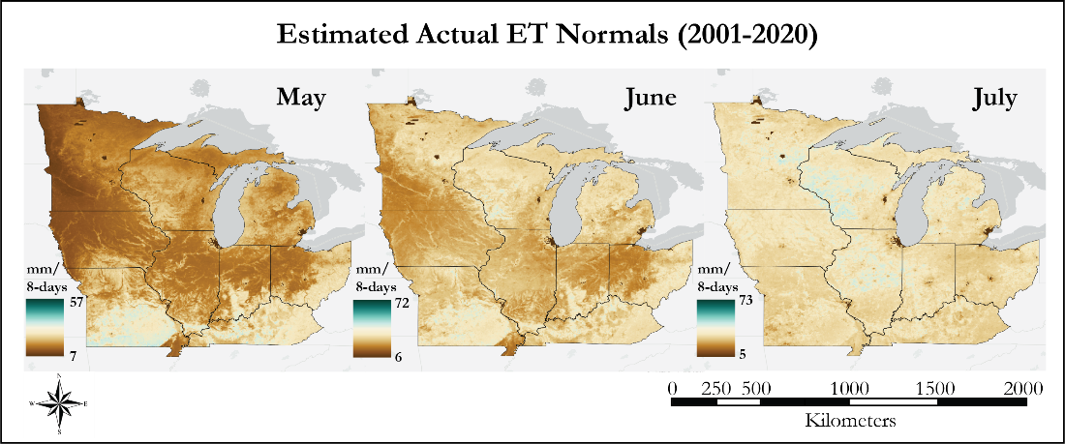

Figure 2. Estimated aET climatology for the Midwestern study area from May to July.

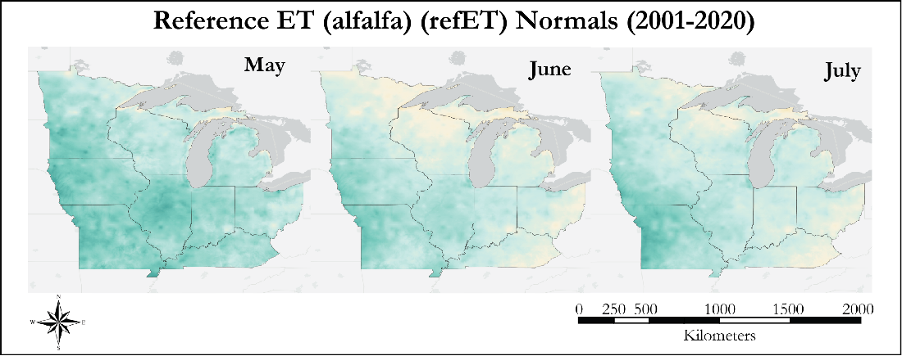

*Figure 3.* RefET climatology for the Midwestern study area from May to July.

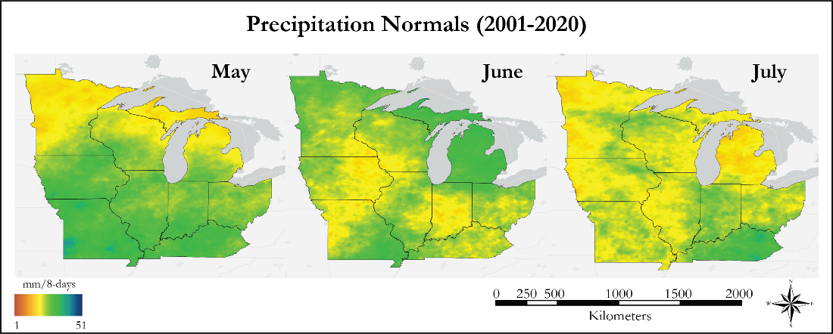

*Figure 4*. Precipitation climatology for the Midwestern study area from May to July.

***4.2 Hydrologic State Results***

Hydrologic state maps provide a partial picture of the water budget in the region by subtracting the main output from agricultural regions, ET, from the main input, precipitation. The aET hydrologic state maps show nearly identical values for the months of January, February, November, and December (Figure B1). Hydrologic state values during these months show a slight water deficit for the majority of the region with the exception of Kentucky, where there is a surplus of water. This surplus appears to be due to increased precipitation in the region shown in the precipitation Normals maps. In the spring months of March and April, aET maps show a water surplus that moves across the study area beginning in the southeast in March and moving across the full study area by April (Figure 5). Interestingly, during the bulk of the growing season (May to September) aET hydrologic state maps show high regional variability, especially in comparison to months outside the growing season. The refET hydrologic state maps give an idea of the difference between the precipitation and the amount of water that could be evaporated or transpired given unlimited supply in the subsurface (Figure 6).

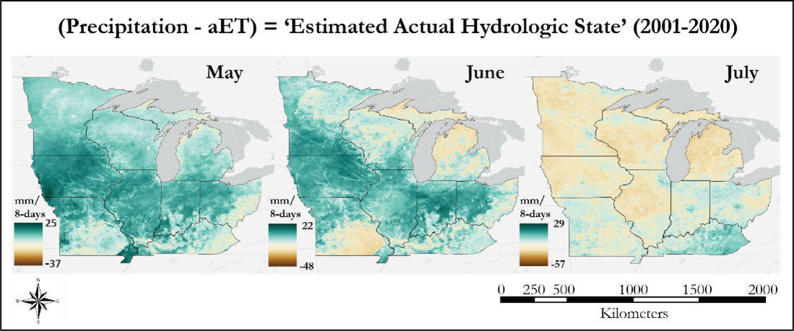

Figure 5. Estimated aET hydrologic state maps for the Midwest study area from May to July.

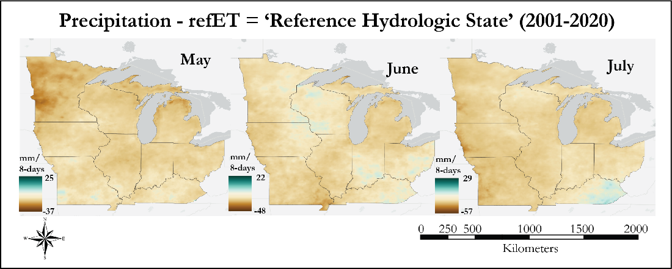

*Figure 6.* RefET hydrologic state maps for the Midwestern study area from May to July.

***4.3 Timeseries Results***

Timeseries plots showing both aET and refET trends from 2001 to 2020 were created for one research station in each of the nine studied states. Actual ET results show an approximate annual peak of 40 mm/8-days each summer. Missouri deviates from these results with average annual peak values of approximately 30 mm/8-days. Kentucky also had annual peaks at approximately 35 mm/8-days. All states show notable disparities in refET and aET during 2012 when the Midwest was affected by an historical drought event. Iowa, Missouri, and Illinois timeseries products appear to capture this event more acutely than other plots (Figure 7). Additionally, an anomalous peak is recorded at the Ohio station in 2013 exceeding values recorded in 2012 (Figure C1). Plots at climate stations in Michigan, Wisconsin, and Indiana reveal periods during which refET and aET are close in range with one another, likely reflecting conditions when atmospheric demand and surface water availability were similar in value (Figure C1).

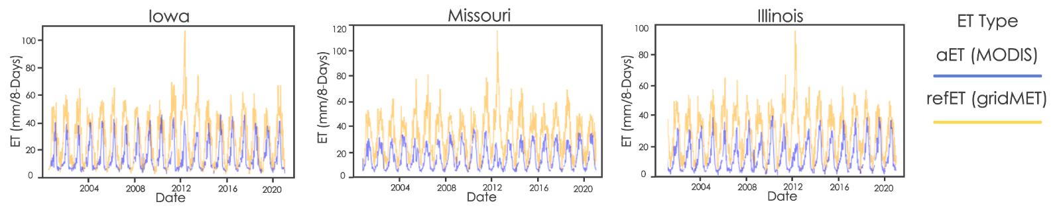

*Figure 7*. Timeseries of the research stations in Illinois, Missouri, and Iowa. The x-axis displays the time period and the y-axis shows ET in millimeters per 8-day composite. The aET from MODIS is represented in blue and the refET from gridMET in orange.

***4.4 Errors & Uncertainties***

Analyses and results in this research were limited by differences in temporal and spatial resolution across remotely sensed datasets utilized. For example, MOD16A2 ET data products are collected in 8-day summation intervals, while gridMET measurements are available as daily values. Additionally, gridMET has a spatial resolution of 4,638.3 meters while MOD16A2 collects information at a 500-meter spatial resolution. Although the methodology allowed for comparison between datasets, the uncertainty propagated by resampling spatially and summing across time was not quantified. This is an important consideration for work that aims to expand upon this feasibility project. Further, *in-situ* data comparison was not within the scope of this project.

During winter months, several of the MOD16A2 images are missing data for a portion of the study area. The worst of these missing data issues occurs in December in northern Minnesota, and an artifact from these missing data is evident in the December aET Normals map. Missing data in the MOD16A2 dataset occurs for several winter months throughout the study period in regions besides northern Minnesota. Additional investigation is necessary to better understand the cause of these missing data. Users of this tool should be aware that averages over time to produce Normals maps likely overemphasize measurements from specific dates on which data were not missing. Some missing data gaps are documented for the MOD16A2 data product and are associated with missing or flagged data throughout yearly data collection. Although modern instrumentation incorporates a gap filling algorithm to assign values to missing pixels, seasonal variability still exists within this dataset (Running et al., 2019). This is especially true during times of high albedo or in areas with limited vegetative cover. Despite limitations, this research establishes a framework for data mining and re-sampling techniques necessary for cross-dataset comparison of ET. Quantifying these sources of uncertainty is a complex issue that should be addressed in future research.

***4.5 Future Work***

Future studies may utilize ground station *in-situ* data measurements and relevant validation methods to assess the accuracy of the MOD16A2 data. Additionally, further investigation of seasonal ET variability in relation to crop type and growing cycles would provide information to guide agricultural planting practices based on crop-specific ET response. This would require calculation of seasonal crop maps to represent the timing, growth cycle, and water cycle effects based on crop type. This includes looking at variations in ET between winter and spring to examine possible anomalies with crops, such as corns and beans, that are harvested at different times in the year.

This research can also be expanded through calculating weekly Normals. ET is a dynamic climate variable which can impact local conditions on a short-term basis. Weekly Normals will allow project partners an opportunity to analyze short-term ET trends. These weekly products may capture the immediate and lasting impacts of extreme events throughout the Midwest that are not represented in monthly climate Normals. In addition, this work can further explore extreme events by calculating anomalies from Normals for specific events such as the 2012 drought.

# 5. Conclusions

The results of this project show the feasibility of measuring ET using remotely sensed data products across the Midwest. The team found that resampling and data mining techniques allowed for a comparison between MODIS and gridMET products. The remotely sensed data, aET, compared as expected with refET data, the latter of which is greater due to the assumption of unlimited water in the subsurface. Work shown here also demonstrates some of the useful insights that can be gleaned from a remotely sensed ET climatology and timeseries products. This project and the associated script provide a framework of how satellite data can be accessed, manipulated, and displayed in a manner useful to project partners. The products generated allow for a qualitative look at ET rates in an agriculturally significant region which can be built upon with continuing research.

Previous studies suggest extreme drought and flooding events will become more frequent in the coming decades, emphasizing the importance of predictive and preparative research on ET. NASA Earth observation data present an opportunity for a spatially complete and reliable data set for ET. This project represents the first steps towards an ET climatology product based on satellite data that may be a valuable contribution to our understanding of water resources and help ensure water and food security in local communities into the future.

# 6. Acknowledgments

The Midwest Water Resources team would like to thank everyone involved for their support and guidance throughout this term. This includes our node Fellow Katie Lange (NASA DEVELOP National Program); science advisors Dr. Olivier Prat (NCEI, North Carolina Institute for Climate Studies) and Dr. Brian Nelson (NCEI, North Carolina Institute for Climate Studies); and project partners Dr. Dennis Todey (USDA Midwest Climate Hub), Molly Woloszyn (NOAA, National Integrated Drought Information System, Midwest Drought Early Warning System), Dr. Jeppe Kjaersgaard (Minnesota Department of Agriculture), Dr. Jeffery Anderson (Michigan State University, Department of Geography) and Dr. Sunita Yadav-Pauletti (USDA Foreign Agricultural Service).

Any opinions, findings, and conclusions or recommendations expressed in this material are those of the author(s) and do not necessarily reflect the views of the National Aeronautics and Space Administration.

This material is based upon work supported by NASA through contract NNL16AA05C.

# 

# 7. Glossary

**Climatology** – The study of climate and its change across time

**Anomaly** – A deviation from the standard or expected outcome within a system

**Hydrologic State** –Proxy measurement for the water budget that is the difference between precipitation and ET

**Earth observations** – Satellites and sensors that collect information about the Earth’s physical, chemical, and biological systems over space and time

**Evaporation** – The process by which water changes from a liquid form to gas vapor; the primary pathway liquid water moves back into the atmosphere in the water cycle

**Evapotranspiration (ET)** – The sum of water lost to the atmosphere by evaporation and transpiration

**Actual ET (aET)** – The amount of ET that occurs under true field conditions

**Reference ET (refET)** – The amount of water lost to the atmosphere based on atmospheric demand and assuming unlimited water resources in the subsurface

**MODIS** – Moderate resolution Imaging Spectroradiometer

**Normals –** Month-by-month averages across 20 to 30 years are referred to as Normals; data from an individual year can be compared with these Normals

**NIDIS –** National Integrated Drought Information Systems

**Transpiration** – The evaporation of water from plant stomata

# 8. References

Abatzoglou, J. T. (2013). Development of gridded surface meteorological data for ecological applications and modelling*. International Journal of Climatology*, *33*(1), 121–131. http://dx.doi.org/10.1002/joc.3413

Fetter, C. W. (2001). Elements of the hydrologic cycle. In *Applied hydrogeology* (pp. 28-32). Prentice Hall.

Hussain, Z. M., Hamilton, S. K., Bhardwaj, A. K., Basso, B., Thelen, K. D., & Robertson, G. P. (2019). Evapotranspiration and water use efficiency of continuous maize and maize and soybean in rotation in the upper Midwest U.S. *Agricultural Water Management*, *221*, 92–98. https://doi.org/10.1016/j.agwat.2019.02.049

Katul, G., Novick, K. *et al*. (2009) *Encyclopedia of Inland Waters.* Academic Press.

https://www.sciencedirect.com/science/article/pii/B9780123706263000120?via%3Dihub

Konapala, G., Mishra, A. K., Wada, Y., & Mann, M. E. (2020). Climate change will affect global water availability through compounding changes in seasonal precipitation and evaporation. *Nature Communications*, *11*,Article 3044. https://doi.org/10.1038/s41467-020-16757-w

Niyogi, D., Jamshidi, S., Smith, D., & Kellner, O. (2020). Evapotranspiration climatology of Indiana using in situ and remotely sensed products. *Journal of Applied Meteorology and Climatology*, *59*(12), 2093–2111. https://doi.org/10.1175/JAMC-D-20-0024.1

Running, S., Mu, Q., & Zhao, M. (2017). *MOD16A2 MODIS/Terra Net Evapotranspiration 8-Day L4 Global 500m SIN Grid V006* [Data set]. NASA EOSDIS Land Processes DAAC. Accessed 2021-10-06 from https://doi.org/10.5067/MODIS/MOD16A2.006

United States Department of Agriculture. (2017). *Agriculture in the Midwest.*

https://www.climatehubs.usda.gov/hubs/midwest/topic/agriculture-midwest

United States Geological Survey. (2021). Evapotranspiration and the Water Cycle. *Water Science School.*

https://www.usgs.gov/special-topic/water-science-school/science/evapotranspiration-and-water- cycle?qt-science_center_objects=0#qt-science_center_objects

Wu Qiusheng (2021). A Python package for interactive mapping with Google Earth Engine, ipyleaflet, and

ipywidgets. https://geemap.readthedocs.io/en/latest/readme.html

# 9. Appendices

**Appendix A**

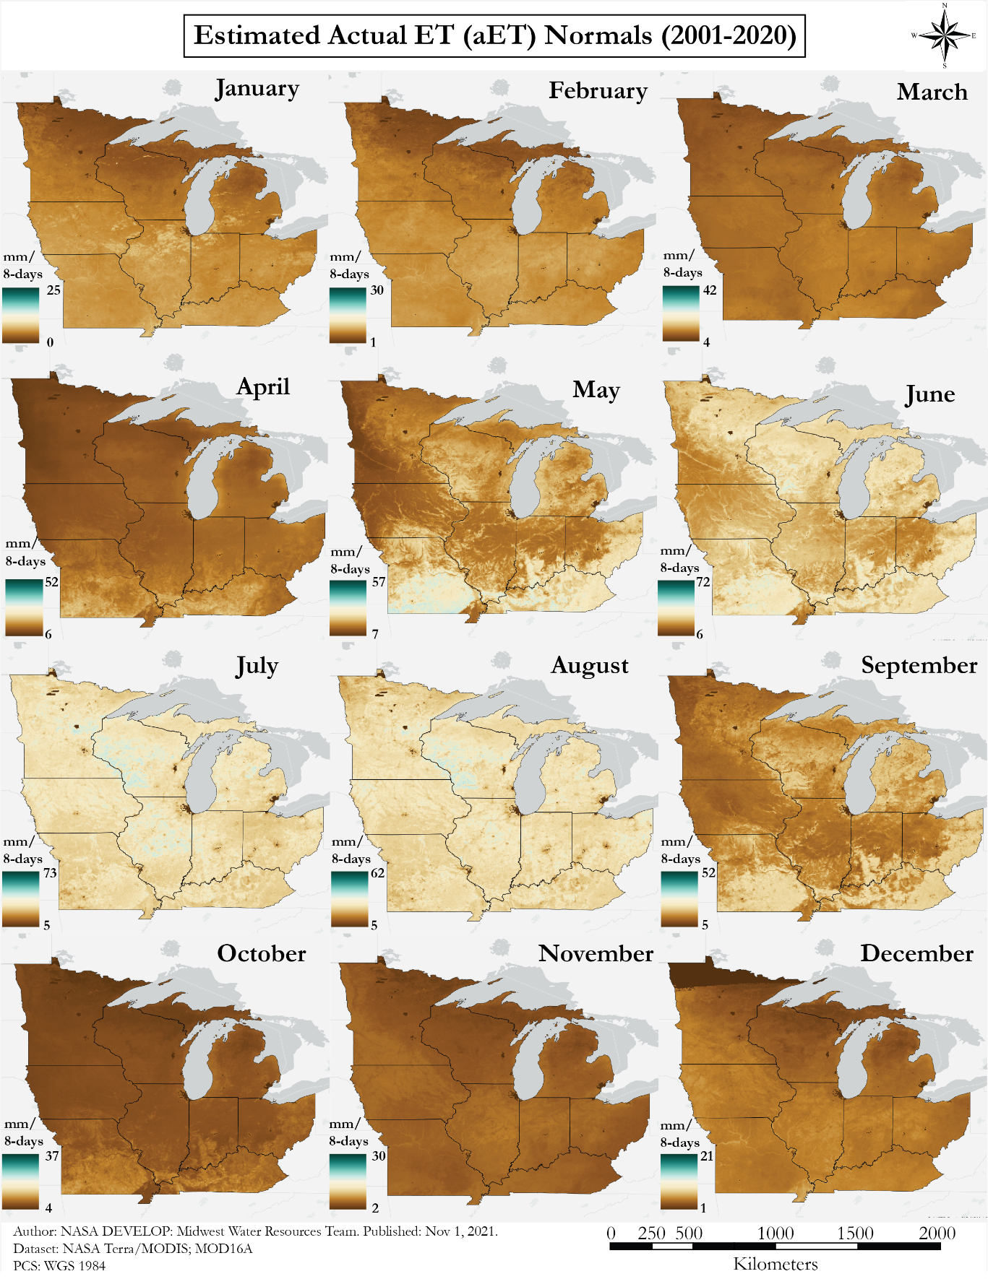

*Figure A1.* Estimated aET Normals derived from MODIS for 2001–2020. Each month has a value range to match the respective refET map. Dark brown represents low ET and gradually shifts to dark blue where ET is greater.

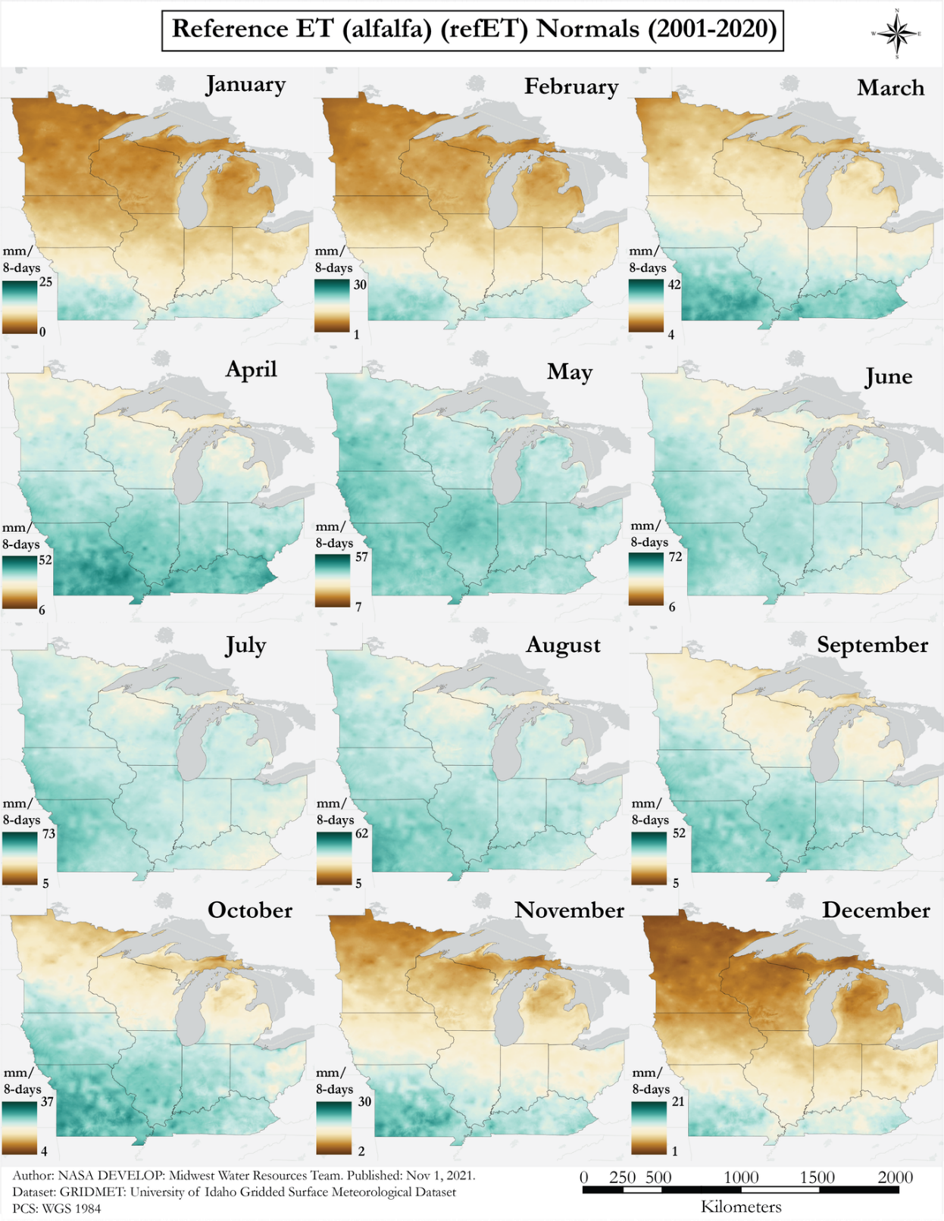

*Figure A2.* RefET Normals derived from gridMET for 2001–2020. Each month has a value range to match the respective aET map. Dark brown represents low ET values and gradually shifts to dark blue where ET is greater.

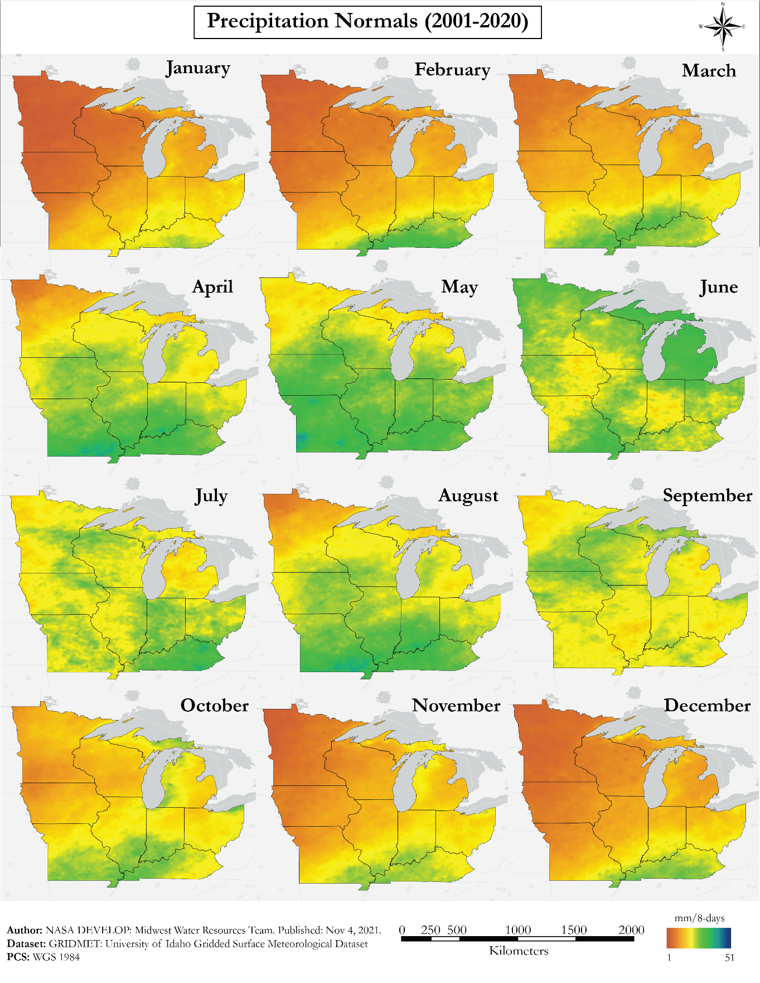

*Figure A3.* Precipitation Normals derived from gridMET for 2001–2020. Maps are displayed with a scale from a minimum of 1 millimeter to a maximum of 51 mm precipitation across the study period. Red represents low precipitation and shifts to cool colors of green and blue where precipitation is greater.

**Appendix B**

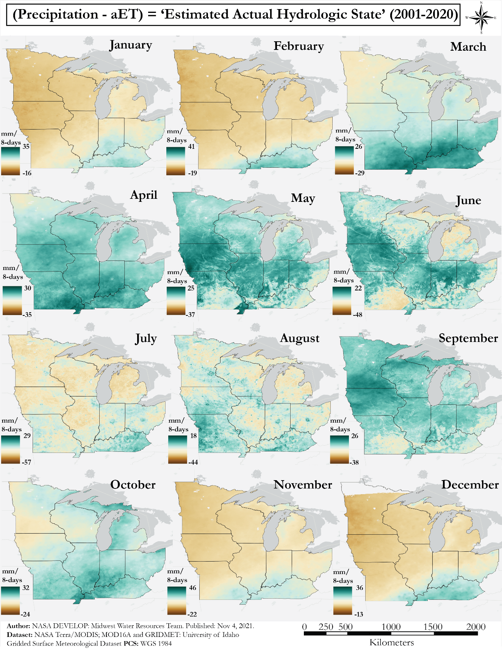

*Figure B1.* Estimated aET hydrologic state map generated through calculation of “Precipitation - aET.” Each month has a value range to match the respective reference hydrologic state map. Dark brown represents low ET values and gradually shifts to dark blue where ET is greater.

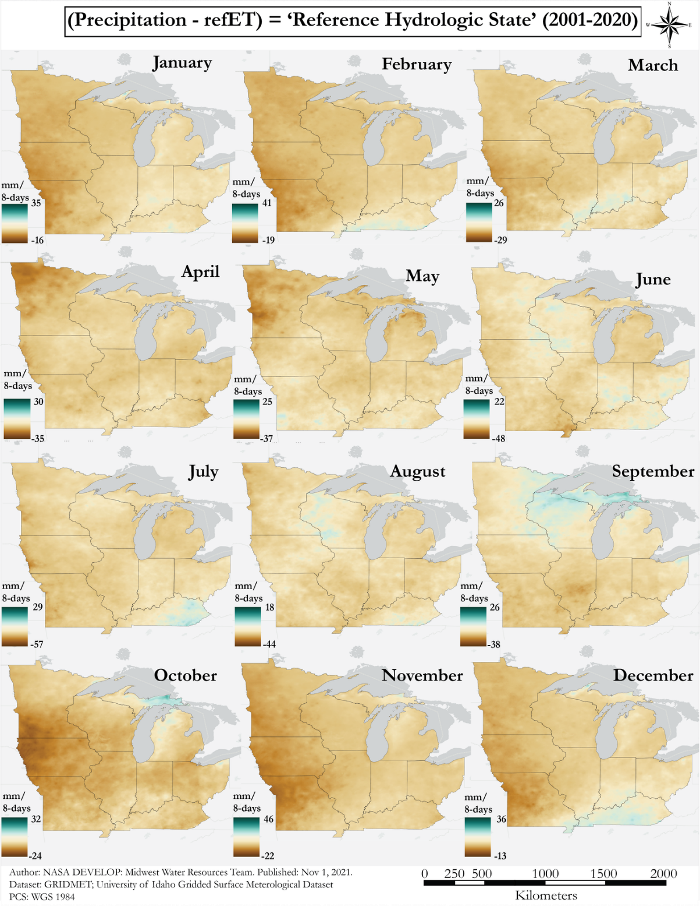

*Figure B2.* RefET hydrologic state map generated through calculation of “Precipitation - refET.” Each month has a value range to match the respective estimated actual hydrologic state map. Dark brown represents low ET values and gradually shifts to dark blue where ET is greater.

**Appendix C**

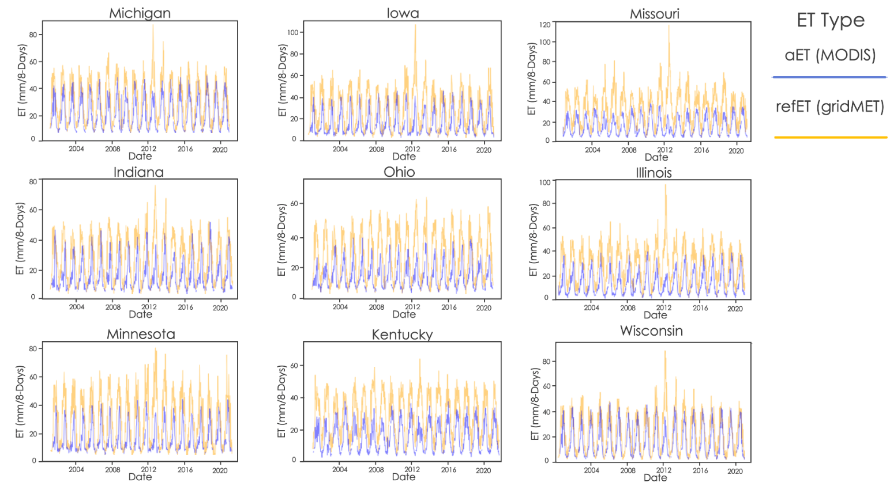

*Figure C1.* Timeseries of ET at each state’s research station. The x-axis displays the time period and the y-axis shows ET in millimeters per 8-day composite. The aET from MODIS is represented in blue and the refET from gridMET in orange.